SWIM SIG Envirolink Tool pre-proposal

Title: Aerial survey system to quantify toxic cyanobacteria cover

Champions: Dr Mark Heath (Lead - Greater Wellington Regional Council)
Shirley Hayward (Environment Canterbury)
Roger Hodson (Environment Southland)

Research Providers: Dr Hamish Biggs, Mr Jo Bind, Dr Cathy Kilroy, Mr Karl Safi (NIWA)
Project Duration: 24 Months

Anticipated budget: $220,000 (excl. GST)

Summary of proposal
An aerial surveying system and software analysis tool will be developed to quantify the cover of toxic cyanobacteria that have proliferated in many rivers across New Zealand over the last 10-15 years (e.g. Phormidium*). The survey system will be designed for use by regional and unitary council staff to improve routine surveillance of sites commonly used for recreational purposes. Existing monitoring methods are time consuming and not very effective for managing potential health risk to humans and livestock. The survey system will provide data for the mandatory periphyton biomass attribute and the potential benthic cyanobacteria attribute (under development) of the National Policy Statement for Freshwater Management (NPS-FM). An associated software tool will be developed for analysis of aerial imagery and assessment of toxic cyanobacteria cover. The use of Red-Green-Blue (RGB), multispectral and hyperspectral imagery will be compared to determine the accuracy of each approach and confirm which is most appropriate for regional council monitoring. The aerial assessment methodology will be documented in a user manual that includes guidance on how to use the software tool and convert toxic cyanobacteria cover to river biomass though ground truthing. The user manual will also include general considerations for aerial monitoring and provide an example of a decision tree framework to assist councils to determine when toxic cyanobacteria monitoring is required.

Key outputs
- An open source Cyanobacteria Aerial Mapping Software (C.A.M.S) tool for analysis of aerial imagery to quantify toxic cyanobacteria cover.
- Documented case studies that demonstrate:
  - How to obtain toxic cyanobacteria cover and biomass estimates.
  - The relative accuracy of toxic cyanobacteria detection using RGB, multispectral and hyperspectral imagery.
  - The accuracy of the C.A.M.S. tool for automatic detection of toxic cyanobacteria (e.g. Phormidium*).
  - The accuracy of biomass estimates from ground truth data.
- A comprehensive user guide that details:
- The aerial assessment methodology.
- How to use the software tool, including the workflow for recording and processing images and algorithms for automatic classification based on spectral signature.
- How to convert Phormidium* cover to biomass with ground truth measurements.
- Other aerial monitoring considerations (e.g., selection of hardware and UAVs, integration with other monitoring such as bankside or in-stream).
- A workshop to train council staff in use of the tool and aerial surveying methods.

Outline of the environmental problem requiring the tool
Toxic cyanobacteria pose a growing management problem for regional and district councils across New Zealand, particularly the benthic cyanobacteria Phormidium* which is widespread in New Zealand rivers. Ingestion of Phormidium* has led to the death of more than 100 dogs and poses a health risk to humans and livestock. Interim guidelines for recreational fresh waters released in 2009 recommend a 3-tier alert system, requiring extensive and time-consuming instream surveys of cyanobacterial cover. However, few councils are resourced to carry out this monitoring and its effectiveness at identifying risks to recreational users is being increasingly questioned. This is because Phormidium* can be patchy in distribution while routine monitoring is generally restricted to transect-based observations at selected recreation sites. This can lead to significant over or underestimates of Phormidium* cover (Figure 1), with the latter having potentially significant consequences for assessment of risks to human (and animal) health. In many cases, Phormidium* proliferations and dog deaths have occurred at sites that are not routinely monitored, resulting in belated postings of warning signage and public criticism of councils. In addition, a significant amount of valuable staff time is often spent trying to investigate and follow-up with concerned councillors and rate payers.
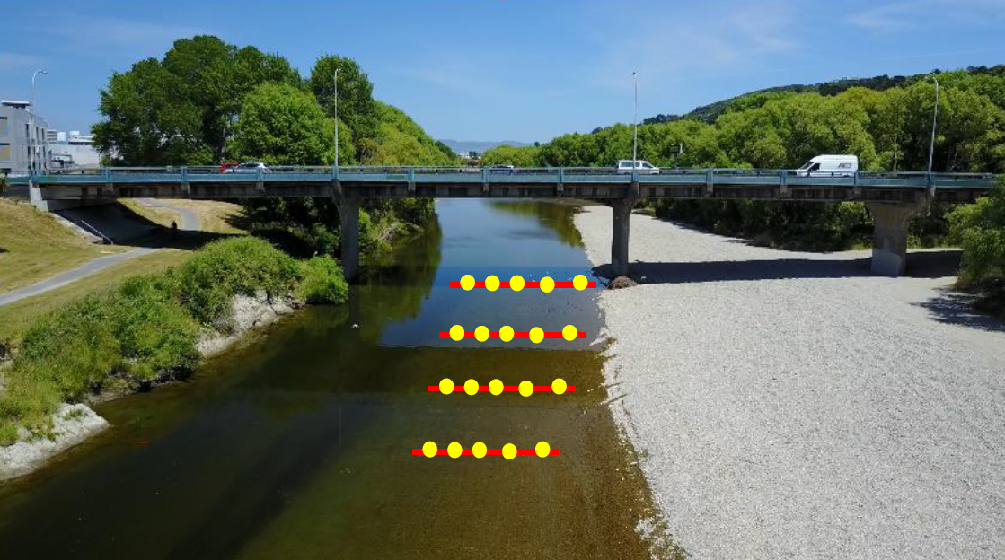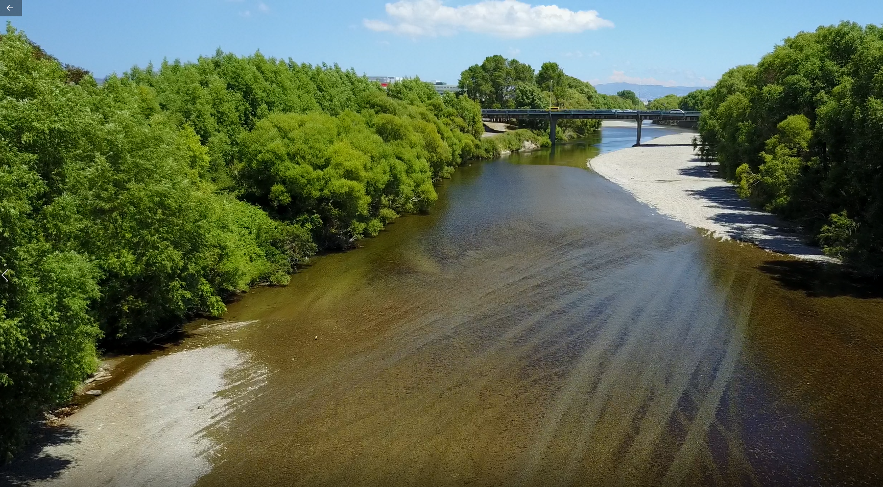
Figure 1: Problems with spot transect monitoring to 0.6 m depth in accordance with current national guidelines (left) to assess cyanobacteria cover. The dark patches in both images indicate dense growths of Phormidium* on the river bed.

The primary advantage of using Unmanned Aerial Vehicles (UAVs) over current spot transect monitoring methods to quantify Phormidium* cover is that reaches of river over 1 km in length can be easily surveyed in high resolution, to obtain a representative estimate of total Phormidium* cover. Cover data can also be converted to biomass estimates through ground truth data, therefore, assisting with information needed to measure performance against ecosystem health objectives for periphyton biomass under the NPS-FM.

The proposed measurement system will provide councils with the capability to perform efficient and repeatable aerial surveys with automated flight paths. It is likely that regional councils will perform rapid visual assessments of aerial imagery when Phormidium* cover is less than 5%. As cover increases (particularly near boundaries between alert and action levels in the national guidelines) more rigorous processing of image data will need to occur (e.g. generation of georeferenced ortho-mosaics and running the C.A.M.S. tool to determine cover).

The aerial footage captured by UAVs during periphyton monitoring may also be valuable for other management purposes (e.g. as an evidence base and communication tool for discussions with the community for water quality and water quantity limit-setting processes under the NPS-FM).

Regional councils are also required by the NPS-FM to measure periphyton biomass in rivers or estimate it from cover assessments. While the focus of this tool is to evaluate Phormidium* cover (since it poses a significant health risk), it is expected that the aerial surveying methods and software developed here can be extended to cover other species and total periphyton biomass in the future. We are confident that Phormidium* can be reliably detected from the air since it is visually distinctive and has a known spectral response (e.g. phycocyanin pigments), however the spectral response of many other species of periphyton is currently unknown. The hyperspectral data obtained during this project may also address some of those knowledge gaps and accelerate future development of a version 2 detection tool that provides quantification of total periphyton cover/biomass.

Alignment with research priorities, strategy and national policy

The proposed aerial survey system and associated C.A.M.S. tool offer a more effective and robust way to quantify Phormidium* cover and biomass in rivers across New Zealand. In particular, this Tool proposal aligns with:
- Priorities contained within the 2014 SWIM SIG Research Strategy, notably national surface water protocols, the ability to provide consistent and representative data for national reporting, and environmental drivers behind benthic cyanobacteria blooms.
- Priority 3 of the Regional Council Research for Resource Management Strategy (2016), specifically: tools for determining land-use effects on surface water quality; and field verification of sustainable water quantity allocation.
- Objective CB1 of the NPS-FM relating to monitoring progress towards, and the achievement of, freshwater objectives and values. Monitoring of benthic cyanobacteria is relevant to two mandatory national values; ecosystem health and human health for recreation.

Past research upon which the tool is based

A Victoria University summer scholarship trial in 2013/14 demonstrated that Phormidium* mats are clearly visible from UAV RGB images. In terms of a proof-of-concept the trial showed that image software could be used to assess Phormidium* cover. The report highlighted that upgrades to the camera imagery and UAV platform and improving the algorithms for image processing software would be needed moving forward.

NIWA routinely use UAVs for river mapping, habitat assessments and vegetation surveys. They have also been developing techniques to efficiently survey freshwater and coastal environments. NIWA is contributing co-funding to the project through the methodological and technical (equipment) developments of: aerial monitoring of aquatic macrophytes in rivers (CDPD1706), flow controls on periphyton and its adaptive management (FWWA1904), hyperspectral camera system (CH19CAPEX 19.804) and the drone flow aerial monitoring system (END19501). NIWA has secured MBIE Smart Ideas funding from October 2018 which will extend their existing capabilities in the use of drones and hyperspectral cameras for river monitoring.

Project team
- Hamish Biggs (NIWA – project lead, UAV pilot and algorithm development)
- Mark Heath (GWRC – project champion, cyanobacteria specialist)
- Shirley Hayward/Tim Davie (ECan)
- Roger Hodson (Environment Southland)
- Jochen Bind (NIWA – surveying and remote sensing)
- Cathy Kilroy (NIWA – ground truth sampling, periphyton biomass/cover relationships)
- Karl Safi (NIWA – processing ground truth samples)
- Brendon Smith (NIWA – UAV technician)
- Juliet Milne (NIWA – resource management)

A Technical Reference Group will also likely be established for the project. Members will include:
- Professor Ian Hawes (University of Waikato – microbial ecology, pant physiology and limnology expert)
- Dr Susie Wood (Cawthron Institute – cyanobacteria expert and author of current monitoring guidelines)
- Associate Professor Ken Ryan (Victoria University of Wellington – an expert in cyanobacteria, light and electron microscopy, and plant physiology)

Council commitment to the tools implementation
The need for this tool was identified by regional council staff present at a Ministry for the Environment workshop in autumn 2018 and has the support of the Surface Water Integrated Management (SWIM) SIG. A workshop to train council staff in tool use will assist councils with its uptake.

Budget details
Project hardware resources (drones, cameras and survey equipment) will be provided in-kind by NIWA while estimated project time, field expenses and training workshop costs are detailed below.

Item | Estimated Cost
Phase 1: Hardware, field deployments and ground truth samples | $40,000
Phase 2: Aerial imagery processing and algorithm development | $50,000
Phase 3: Software tool development | $50,000
Phase 4: User guide preparation | $54,000
Phase 5: Training workshop and end user support | $26,000
Total: | $220,000

NIWA deploy small drones (DJI Phantom 4 Pro) for routine aerial imagery jobs, and larger drones (DJI Matrice 600 Pro) for aerial laser scanning, multispectral, or hyperspectral imagery. NIWA have consumer grade RGB cameras, mid-range multispectral cameras (6 spectral bands), and a high end hyperspectral camera (281 spectral bands). This hardware selection will enable a rigorous comparison of the Phormidium detection accuracy attainable with different levels of hardware. It will also enable the optimal spectral bands for Phormidium detection to be determined, which will improve the selection of band pass filters for multispectral cameras.

